# Git Setup

1. Create free account : Atlasian.com

Use this account , when login to source Tree

1. Download Source tree (free)

<https://www.techspot.com/downloads/6740-sourcetree.html>

1. Click install above download Select Git during
2. Login atlasain account
3. Choose only GIT to isntall
4. Select no

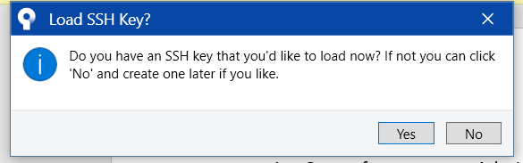

1. open soure ctree
2. clone following Git Repository (https://github.com/MyCodeFriday/Azure.git
3. open and click clone button on menu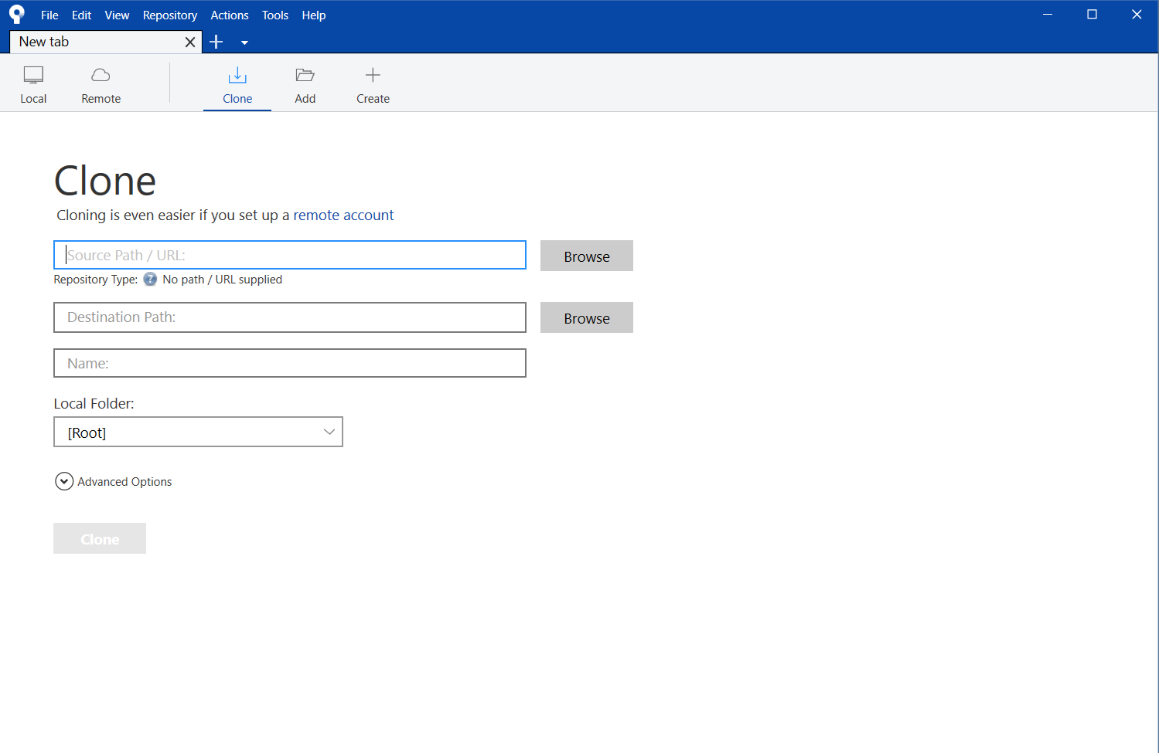
4. 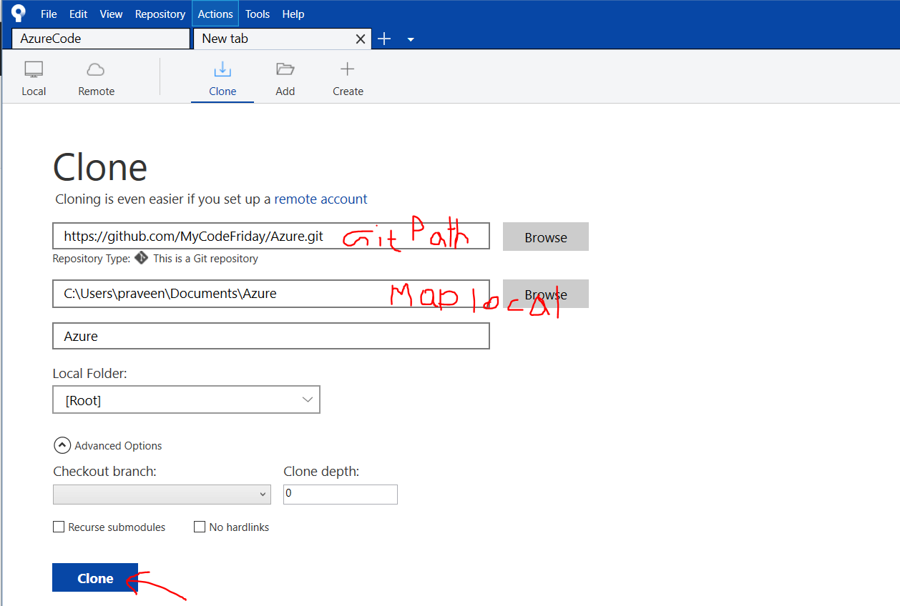
5. if above install does not works ofr Git command line . Please download and install <https://gitforwindows.org/> GIT for windows
6. 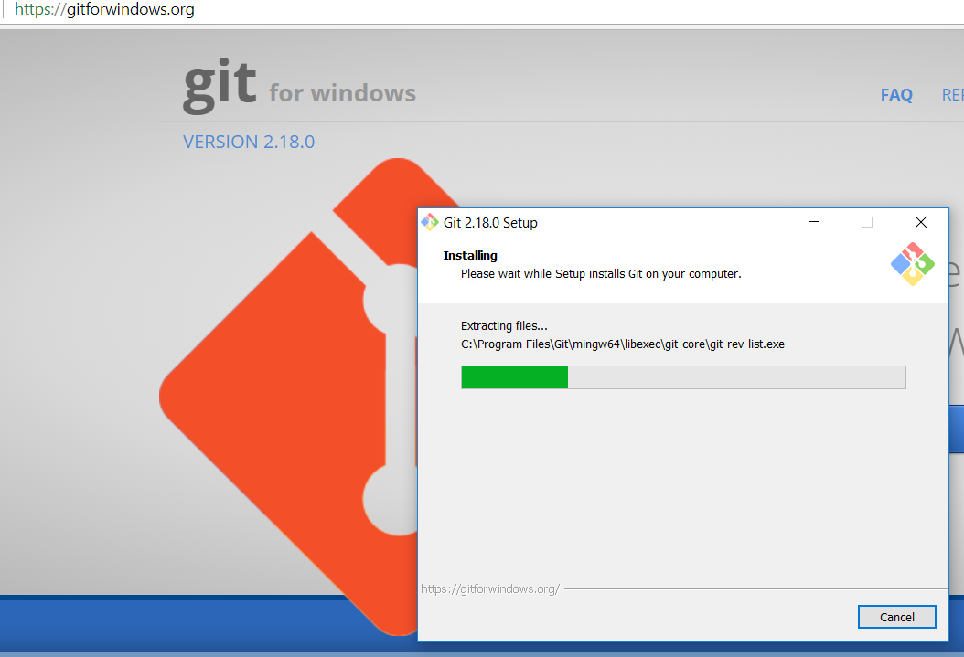

Setup command bash (only needed if want code merge to this rep)

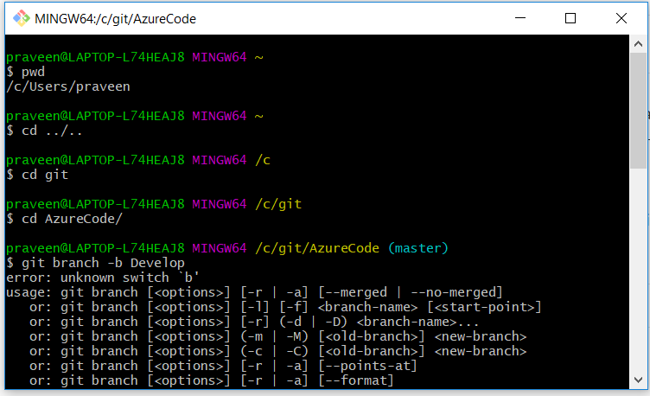

Additional info :

Links

<https://www.youtube.com/watch?v=9pa_PV2LUlw>

# USQL docs

<https://saveenr.gitbooks.io/usql-tutorial/content/getting-started/your-first-usql-script.html>

<https://azure.github.io/AzureDataLake/>